**Please download the Sai Baba Prayer Center Android App using the QR code below:**

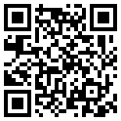

Please feel free to share the app.

If there are any changes you would like to see, please feel free to contact me at [vayelisetti@gmail.com](mailto:vayelisetti@gmail.com) or leave a review on the app in the Google Play store.

I would love to hear your feedback.